Student Services Centre UM  Profileringsfonds Secretariat  profileringsfonds@maastrichtuniversity.nl | To be completed by SSC  code: PF.  date of receipt:

Profileringsfonds Regulations
Application Form force majeur
2023-2024

STRICT DEADLINE!
The application for financial support for study delay, due to special circumstance(s) of force majeure occurred in the academic year 2023-2024, must be submitted to the Student Services Centre, Secretariat Profileringsfonds via profileringsfonds@maastrichtuniversity.nl
between 1 September 2024 and 1 March 2025 and at least 2 months before de-registration.
Note: in case you graduate or terminate your studies during the academic year 2023-2024, the application must be submitted at least two months before you de-register.
An application submitted on or after 1 March 2025, will not be processed

Part I Application (to be completed by the student)

Information applicant:

Name: | Surname:
Initials: | Faculty:
Student ID-number:

Name account holder:

IBAN account number:

The aforementioned bank account number will only be used to transfer financial support due to study delays incurred when awarded under the Profileringsfonds Regulations. Payment of this support can only be made while you are enrolled as a full-time student.

1. I have experienced the following circumstance: (multiple options possible):
☐ illness ☐ pregnancy/childbirth
☐ handicap/(chronic) illness ☐ infeasible study programme
☐ exceptional family circumstance(s) ☐ circumstance(s) justifying appeal to the
hardship clause
the circumstance(s) occurred:
☐ from ……………………. up to and including ……………………….. during the academic year 2023-2024
☐ during the entire academic year 2023-2024
☐ during the entire academic year 2023-2024 and continues up to the present

2. The month and year in which the circumstance(s) occurred for the first time:
(if the circumstance(s) occurred / arose before the academic year 2023-2024, state this date)
Year: ………………………………………………………………………
Month: ……………………………………………………………………

3. The circumstance(s) were:
☐ not previously reported to the Study Adviser/Student Dean/Disability Support;
☐ were reported to: ☐ the Study Adviser, on: ……………………………………………………………….
☐ the Student Dean, on: ……………………….………………………………………
☐ Disability Support, on: ……………………………………………………………….

4. Complete only if you chose “illness” or “handicap/(chronic) illness” under sub 1. Otherwise, you can skip this subsection and continue with sub 5.
I received Dutch student finance via DUO during academic year 2023-2024:
☐ yes, add the most recent “DUO-bericht” (see example below)
☐ no

5. I have submitted a request to DUO for an extension of the performance grant in the past:
☐ no
☐ yes, on ……………………………………………………………………………………………………………………………..
Has this request been approved by DUO?
☐ yes
☐ no

ENCLOSE
Please submit the following documents with your application form:

- statement(s) and/or proof regarding the nature and duration of the circumstance(s).

- In case of illness or handicap/(chronic) illness: the most recent “DUO-bericht”
Log in to ''Mijn DUO'' > tab: “Mijn producten” > overview “Resterende studiefinanciering”.
See: https://www.duo.nl/particulier/logging-in-to-mijn-duo.jsp
Note: take a screenshot on which your name (top right) is also visible.
For a correct overview, see the example below. (Unfortunately, “Mijn DUO” is only in Dutch, but you can use your browser to translate).
Your name
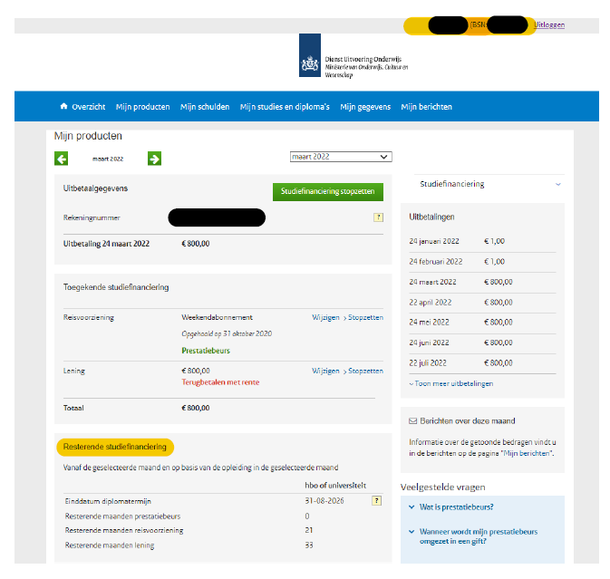

Explanation why the circumstance(s) led to study delay in academic year 2023-2024:

I have completed the above, stated on pages 1 up to and including 4, truthfully.

Name:  Date: | Signature student:

Exchange of information
The Student Dean advises the director of the Student Services Centre (SSC) about this application. Therefore, it is important that all the necessary information is available. To this end, the Student Dean can request additional information from the Study Adviser and/or Disability Support.
By submitting this application, you consent to consultation between the Student Dean and the Study Adviser and/or Disability Support regarding your application.

PART II Explanatory notes of the Study Advisor regarding reporting the circumstances and measures taken to limit study delay

Student (name):…………………………………………………………………………………………………………………………..
has reported the circumstance(s) mentioned in PART I on (date):…………………………………………….

This circumstance(s) played/plays out during the period mentioned in PART I under subsection 1.
☐ yes
☐ no, please elaborate ………………………………………………………………………………………………………………….

Were agreements reached/measures taken during academic year 2023-2024 with reference to these circumstance(s)?
☐ no
☐ yes, relating to: ☐ study planning
☐ termination/interruption of enrollment
☐ other, namely: …………………………………………………………………………..

Explanation of agreements made, measures taken or topics discussed:
(such as temporary interruption of study)

Initials Study Adviser:
PART III Explanatory notes of the Study Adviser to the study delay

Option ECTS allocated
1. Credits to be obtained by the student aforementioned in the academic year 2023-2024, based on the study program according to the Education and Examination Regulation (OER):…………………………
2. Credits obtained by this student in the academic year 2023-2024: ……………………………………………..

Option no ECTS allocated
If study delay cannot be stated in ECTS, number of months of study delay: …………………………………….
Enclose: overview study planning academic year 2023-2024 and 2024-2025 to substantiate extent of study delay, e.g. original and modified master track.

Causal relationship between study delay and the circumstance:

☐ of the total study delay incurred in the academic year 2023-2024:
…………………………………………….… ECTS
……………………………….…………….. months
can be attributed to the circumstance(s) mentioned in Part II.

☐ the study delay in the academic year 2022-2023 is, in my opinion, not due to the circumstance(s) mentioned in Part II.

☐ I cannot assess whether the study delay in the academic year 2023-2024 can be attributed to the circumstance(s) mentioned in Part II.

Explanation of the causal relationship between study delay and the special circumstance(s):

Name:  Date: | Signature Study Adviser:

