Student Services Centre UM  Profileringsfonds Secretariat  profileringsfonds@maastrichtuniversity.nl | To be completed by SSC  code: PF.  date of receipt:

Regulation Profileringsfonds
Application Form force majeur
2022-2023

STRICT DEADLINE!
The application for financial support for study delay, due to special circumstance(s) of force majeure occurred in the academic year 2022-2023, must be submitted by the student to the Student Services Centre, Secretariat Profileringsfonds via profileringsfonds@maastrichtuniversity.nl
between 1 September 2023 and 1 March 2024 and minimum 2 months before de-registration.
Note: in case you graduate or terminate your studies during the academic year 2022-2023, the application must be submitted at least two months before you de-registering.
An application submitted on or after 1 March 2024, will not be processed

Part I Application (to be completed by the student)

Information applicant:

Name: | Surname:
Initials: | Faculty:
Student ID-number:

Name account holder:

IBAN account number:

The aforementioned bank account number will only be used to transfer financial support due to study delays incurred when awarded under the Regulation Profileringsfonds academic year 2022-2023. Payment of support can only be made while you are enrolled as a full-time student.

1. I have experienced the following circumstance: (multiple options possible):
☐ illness ☐ pregnancy/delivery
☐ handicap/(chronic) illness ☐ insufficient feasible study
☐ exceptional family circumstance(s) ☐ circumstance(s) justifying appeal to the
hardship clause

the circumstance(s) occurred:
☐ from ……………………. up to and including ……………………….. during the academic year 2022-2023
☐ during the entire academic year 2022-2023
☐ during the entire academic year 2022-2023 and continue(s) to the present

2. The month and year in which the circumstance(s) occurred for the first time:
(if the circumstance(s) occurred / arose before the academic year 2022-2023, state this date)
Year: ………………………………………………………………………
Month: ……………………………………………………………………

3. The circumstance(s) were:
☐ not previously reported to the Student Advisor/Student Dean/Disability Support;
☐ were reported to: ☐ the Study Advisor, on: ……………………………………………………………….
☐ the Student Dean, on: ……………………….………………………………………
☐ Disability Support, on: ……………………………………………………………….

4. I have submitted a request at DUO to extent the performance-related grant previously:
☐ no
☐ yes, on ……………………………………………………………………………………………………………………………..
Has this request been approved by DUO?
☐ yes
☐ no

ENCLOSE
Please submit the following documents with your application form:
- statement(s) and/or proof regarding the nature and duration of the circumstance(s).
- the most recent ‘DUO-bericht’
Log in to ''Mijn DUO'' > tab: ‘Mijn producten’ > overview 'Resterende studiefinanciering'.
See: https://www.duo.nl/particulier/logging-in-to-mijn-duo.jsp
Note: take a screenshot on which your name (top right) is also visible.
For a correct view, see the example below. (Regretfully ‘Mijn Duo’ is only in Dutch, but you can
use your browser to translate).
Your name
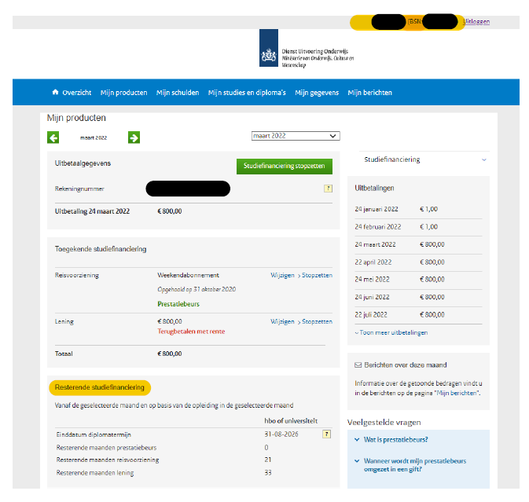

Explanation why the circumstance(s) led to study delay in academic year 2022-2023:

I have completed the above, stated on page 1 up and including 4, truthfully.

Name:  Date: | Signature student:

Informatie uitwisselen
The student dean will advise the director of Student Services Centre (SSC) about this application. Therefore, it is important that they have all the necessary information. To this end, the student dean can request additional information from the study adviser and/or Disability Support.
By submitting this application, you consent to consultation between the student dean and the study adviser and/or Disability Support regarding your application.

PART II Explanatory notes to the circumstances
(to be completed by the study adviser)

The undersigned, name:………………………………………………………………………………………………………………………..

declares that student …………………………………………………………………………………………………………………………….

ID-number ………………………………………………………………………………………………………………………………..…………

reported on ………………………………………………………………………………………………….………………………………………

the circumstance(s) specified in PART I and confirms that this circumstance played/plays during the period mentioned in PART I under subsection 2.
Explanation if different ………………………………………………………………………………………………………………….

Were agreements reached during academic year 2022-2023 with reference to these circumstance(s)??
☐ no
☐ yes, relating to: ☐ study planning
☐ termination/interruption of enrollment
☐ other, namely: ………………………………………………………

Explanation of agreements made or topics discussed:
(such as temporary interruption of study)

PART III Explanatory notes to the study delay
(to be completed by the study adviser)

Option ECTS allocated
1. Credits to be obtained by the student aforementioned in the academic year 2022-2023, based on the study program according to the Education and Examination Regulation (OER):…………………………
2. Credits obtained by this student in the academic year 2022-2023: ……………………………..

Option no ECTS allocated
If study delay cannot be stated in ECTS, number of months of study delay: ………………………………….
Enclose: overview study planning academic year 2022-2023 and 2023-2024 to substantiate extent of study delay, e.g. original and modified master track.

Causal relationship between study delay and the circumstance:

☐ of the total study delay incurred in the academic year 2022-2023:
…………………………………………….… ECTS
……………………………….…………….. months
is attributable to the circumstance(s) mentioned in Part II.

☐ the study delay in the academic year 2022-2023 is, in my opinion, not due to the circumstance(s) mentioned in Part II.

☐ I cannot assess whether the study delay in the academic year 2022-2023 is attributable to the circumstance(s) mentioned in Part II.

Explanation of the causal relationship between study delay and the special circumstance(s):

Name:  Date: | Signature study adviser:

