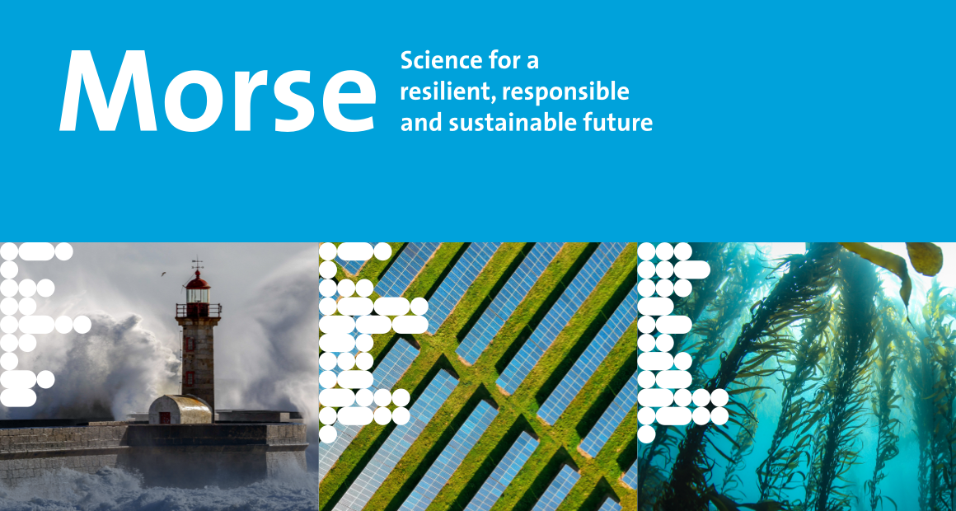
Call for Papers
Maastricht Observatory for Responsible, Resilient and Sustainable Societies, Economies and Enterprises
3rd Annual Conference 2023
Track: Circular Business Models
Maastricht, the Netherlands, 23-25 October 2023

Track Chairs:
Laura Niessen, Julia Smid and Clarence Bluntz

Description of the track
The circular economy is gaining traction, with governments and business implementing it to bring about environmental sustainability, job creation or economic growth. In a circular economy, natural capital is preserved by keeping products and materials in use and removing wastes and negative externalities. Companies play a pivotal role in bringing about circular resource flows. They can decide to change their processes from the current linear make-take-dispose system to a circular system that retains value. By cycling resources, extending lifetimes and intensifying product use, businesses can create income opportunities while reducing resource use and wastage. To do so, they can adapt a circular business model.
Circular business models can reduce the environmental impact of businesses, their suppliers, and their consumers through retaining value for longer. Pillars for business circularity include narrowing, slowing, closing and regenerating loops. Narrowing includes efficiency and process improvements, while slowing refers to keeping products in use for longer. Both pillars also promote sufficiency in consumer behaviours. Closing refers to cycling resources after their use to ensure the materials value is retained. Regenerating means addressing existing degradation by rebuilding environmental and social capacities. Through strategies such as the 9-Rs (reduce, rethink, reuse, etc.), businesses can move from a linear to a circular business model. Moreover, through supply chain collaboration, an industry’s supply chain can be reconfigured, which means circularity can be achieved on an industry scale. Experimentation with circular business models and circular pilots are increasingly popular, as are established circular offers. Yet, there are many remaining questions around the future of circular business models that need to be addressed by research.

Key topics and research questions of the track

- Key topics include, but are not limited to:
  - Circular business model implementation and scaling
  - Sufficiency, regenerative, degrowth and post-growth business models
  - Circularity along the value chain

- Key questions include, but are not limited to:
  - Which change processes are required in a business, in an economy and by government and consumers to facilitate the implementation and uptake of circular business models?
  - What are the actual impacts of circular business models, on the environment and on society? How can these impacts be measured and compared?
  - How to best implement and scale circular business models?
  - How to integrate the sufficiency pillar into circular business models and promote sustainable consumption or decrease in consumption?
  - How to integrate the regeneration pillar into circular business models and ensure that businesses increase positive impact rather than decrease negative impact?
  - What is the role of circular business models in transitioning towards a degrowth or post growth economy?
  - How to implement circular business models throughout the value chain, for instance with suppliers?
  - How are circular business models perceived by customers and how can uptake be promoted?
  - How can digitalisation support the implementation and scaling of circular business models?

References:
Bauwens, T. (2021). Are the circular economy and economic growth compatible? A case for post-growth circularity. Resources, Conservation and Recycling, 175. https://doi.org/10.1016/j.resconrec.2021.105852

Bocken, N., de Pauw, I., Bakker, C., & van der Grinten, B. (2016). Product design and business model strategies for a circular economy. Journal of Industrial and Production Engineering, 33(5), 308-320. https://doi.org/10.1080/21681015.2016.1172124

Bocken, N. M. P., Niessen, L., & Short, S. W. (2022). The Sufficiency-Based Circular Economy—An Analysis of 150 Companies. Frontiers in Sustainability, 3. https://doi.org/10.3389/frsus.2022.899289

Geissdoerfer, M., Pieroni, M. P. P., Pigosso, D. C. A., & Soufani, K. (2020). Circular business models: A review. Journal of Cleaner Production, 277. https://doi.org/10.1016/j.jclepro.2020.123741

Hofmann, F. (2019). Circular business models: Business approach as driver or obstructer of sustainability transitions? Journal of Cleaner Production, 224, 361-374. https://doi.org/10.1016/j.jclepro.2019.03.115

Konietzko, J., Bocken, N., & Hultink, E. J. (2020). Circular ecosystem innovation: An initial set of principles. Journal of Cleaner Production, 253, Article 119942. https://doi.org/10.1016/j.jclepro.2019.119942

Luedeke-Freund, F., Gold, S., & Bocken, N. M. P. (2019). A Review and Typology of Circular Economy Business Model Patterns. Journal of Industrial Ecology, 23(1), 36-61. https://doi.org/10.1111/jiec.12763

Velenturf, A. P. M., & Purnell, P. (2021). Principles for a sustainable circular economy. Sustainable Production and Consumption, 27, 1437-1457. https://doi.org/10.1016/j.spc.2021.02.018

The deadline for submissions is 1 July, 2023.
All submissions must use the submission template and use the submission procedure on the webpage otherwise they will not be considered for review.
Submit your paper here.

The registration for the MORSE 2023 will be open until 31st August, 2023.
Register here.

