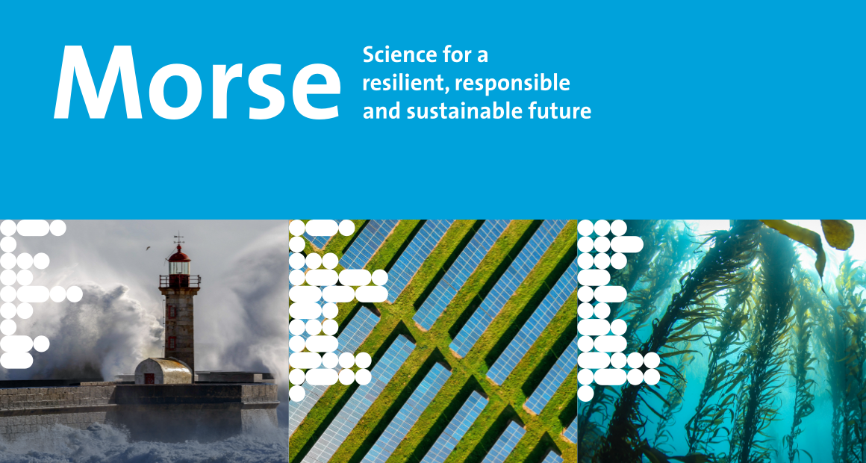
Call for Papers
Maastricht Observatory for Responsible, Resilient and Sustainable Societies, Economies and Enterprises
3rd Annual Conference 2023
Track: Responsible business
Maastricht, the Netherlands, 23-25 October 2023

Track Chairs:
Rob Bauer, Wim Gijselaers, Ann Vanstraelen, and Iver Wiertz (co-chair)

Description of the track
The call for responsible companies is getting louder. Society is rightly demanding more responsible leadership. Managing the classic production factors has become increasingly complex due to new externalities such as climate change. However, many companies still tend to focus on short-term firm benefits of shareholders rather than on long-term sustainable value creation for diverse stakeholders. Corporate governance for sustainable and competitive companies has therefore become a strategic issue for the European Commission. This includes better risk management and the provision of reliable corporate information that facilitates decision-making and influences firm behaviour. This requires responsible accounting and governance, and ultimately responsible finance as a catalyst for responsible business.
We are just beginning to understand how these necessary transformations affect firm performance, organizational design, organizational culture, and corporate leadership and a range of questions remains for us to further explore. For instance, how can we train and prepare leaders and employees for situations and problems which by its very nature are ill-defined, dynamic, and complex or present wicked ethical dilemmas? Further questions are related to defining what are norms and values that constitute a responsible and ethical organization, and how these norms and values can be integrated in the culture, design, and structure of organisations. This track aims to facilitate discussion and stimulate contributions to this multidisciplinary and burgeoning field of research by addressing questions that hold relevance and are prevalent to a wide variety of organisations and practitioners.

Key topics and research questions of the track

- Key topics include:
  - Responsible business that promotes long-term success
  - Sustainable corporate governance
  - Accounting for a sustainable economy (ESG measurement, reporting and assurance)
  - ESG and the role of capital providers
  - Framing and making sense of sustainability issue by top-management and leaders

- Key questions include:
  - How to make sustainability part of a company’s DNA? How to embed responsibility and sustainability in business? How to integrate (conflicting) interests of key stakeholders into business decisions?
  - How does top-management make sense of sustainability and frame sustainability issues they are facing? What are its effects on investors, firm performance, and human capital?
  - What does it require from organizational leaders to act as responsible leaders and to become such a leader?
  - What are the key barriers and enablers for organizational change? What are the implications for learning and development of its leaders and employees?
  - How to close the gap between the sustainability/climate rhetoric and reality?
  - How to value climate investments?
  - What hampers sustainable investments?
  - How to quantify firm-level exposure to climate risks and climate change, and its financial impact? How do financial analysts process climate information?
  - How to measure ESG performance, and what is the role of assurance in ensuring reliable ESG reporting?

References:
- van Aartsen, C., Bauer, R., Bauer, T., & Olaerts, M. (2022). Sustainability embedding in Dutch listed companies. Vba Journaal, 37(149), 32-38.

- Kirsch, L., Gijselaers, W., Lokshin, B. & Vanstraelen, A. (2023). Responsible leadership: A multi-level framework and an agenda for moving forward. Working paper, Maastricht University.

- Feeney, M.F., Grohnert, T., Gijselaers, W.H., Martens, P., &. (2022). Organizations, learning and sustainability: A cross-disciplinary review and research agenda. Journal of Business Ethics https://doi.org/10.1007/s10551-022-05072-7

- Pankratz, N., Bauer, R., & Derwall, J. (2023) Climate Change, Firm Performance, and Investor Surprises. Management Science. Forthcoming. https://doi.org/10.1287/mnsc.2023.4685

The deadline for submissions is 1 June, 2023.
All submissions must use the submission template and use the submission procedure on the webpage otherwise they will not be considered for review.
Submit your paper here.

The registration for the MORSE 2023 will be open until 31st August, 2023.
Register here.

