Experience Day
Medicine

Programme

Programme Groups 1 and 2
Time | Activity
13.00-13.10 | Welcome at our Randwyck Campus
13.10-13.30 | Welcome by our student ambassadors about the programme and programme of the day
13.30-14.30 | Learning Team Session
14.30-15.30 | Skillslab
15.30-16.00 | Campus tour Randwyck Campus
16.00-16.30 | Expert meeting
16.30-17.00 | Q&A with our student ambassadors

Learning team session

Programme Groups 3 and 4
Time | Activity
13.00-13.10 | Welcome at our Randwyck Campus
13.10-13.30 | Welcome by our student ambassadors about the programme and programme of the day
13.30-14.30 | Skillslab
14.30-15.30 | Learning Team Session
15.30-16.00 | Campus tour Randwyck Campus
16.00-16.30 | Expert meeting
16.30-17.00 | Q&A with our ambassadors

Follow-up

A few days after the event, you will receive an email with information about the admission procedure and how to get in contact with us.

BA-MED and learning in groups

In the Bachelor of Medicine, you work in small groups according to the principles of Problem-Based Learning (PBL). This offers you a different way of learning from traditional university education. You work in a learning team, engage in hands-on training and have interactive lectures, so called expert meetings, for which you prepare.

Under the guidance of a learning team coach, in the learning team you work on the Authentic Professional Task (APT) and tackle real-life challenges. PBL is an active way of learning that gives you better retention of knowledge, enhances your motivation and encourages you to develop skills that are essential for the labour market in the 21st century.
In the learning team, you work together and are responsible (under guidance of the coach, of course) for what you learn. This requires you to play an active role in the learning process.

In short: PBL is about learning how to learn and becoming competent in the intended learning outcomes, you learn together in a dynamic way, supporting you in your professional and personal development.

Some advantages
You learn together, in a dynamic way
Because you work actively on real-life issues and authentic tasks, the theory sticks better in your mind and you learn to apply your knowledge to all sorts of questions. The very different backgrounds of your fellow learning team members not only make for lively discussions, but also mean you gain experience cooperating in culturally diverse teams.
You acquire skills for life
Our graduates serve as the evidence that the principles are effective and support your learning. Our graduates are independent and professional, and meet the required end-objectives of the programme. They are especially skilled in analysing complex issues, gathering and structuring information, working in international teams, leading discussions, and forming and presenting ideas.

What happens in the learning team

Course periods revolve around Authentic Professional Tasks (APTs), which serve as the entry point for learning. Students work in Learning Teams of 8-10 students. Based on the learning materials and activities offered, learning teams develop and manage their own plans for the period. They spend their meeting time on a choice of pre- or post-discussing learning tasks, collaborating on group assignments, doing evaluation quizzes, presenting topics of interest, preparing for expert meetings, etc. Different teams show different approaches in order to achieve the APTs learning objectives. Students systematically collect information about their individual progress and performance with respect to the learning objectives. Each learning team is supervised by a Learning Team Coach (LTC).

The APT in the 1st period Acute Care I

The Authentic Professional Task is: Recovery of an acute patient on the street
In this period, you will learn what to do when you find someone in distress on the street. Knowledge of, and care for vital functions (heart, lungs, circulation) are paramount.
You will start working with evidence-based medicine and will learn how to search for scientific literature. You’ll learn how to consider your own emotions when acting as a healthcare professional, as well as your jurisdiction and integrity and professional confidentiality.

During this period, you will learn the structure of the acute care chain within the organisation of the (inter)national care system. You become acquainted with this curriculum, with choosing a personal pathway within it and with training your own study skills. Parallel to the Acute Care topic, you will start with the longitudinal programme of learning to perform a consultation with an ABCDE stable patient visiting a general practice with a common complaint.

I: In the first 1-2 learning team meetings, they make a planning for the period (10 weeks).
See below for an (imaginary) example:

Learning team meeting |  | Plan
Week 1 | Monday | Explore Authentic Professional Task, outline, assignments, deadlines, etc.
 | Thursday | Fill in period planning (outline) + Discuss learning task 1
Week 2 | Monday | Discuss group debate + divide tasks for preparation
 | Thursday | Discuss learning task 2 + prepare for expert meeting I
Week 3 | Monday | Learning task 3 + state of affairs debate preparation
 | Thursday | Discuss difficult topics learning tasks 1-3
Week 4 | Monday | Discuss difficulties self-evaluation quiz 1
 | Thursday | Start working on group writing assignment
Week 5 | Monday | Evaluation group dynamics
 | Thursday | Learning tasks 4 and 5
Week 6 | Monday | Expert meetings: What have we learned so far? Apply to cases
 | Thursday | Self-evaluation quiz
 |  | Etc…
 |  | Etc…
Week 10 | Monday | Peer Q&A: help each other with the last bits
 | Thursday | Final evaluation + informal get together

II: As part of the learning activities, learning tasks are offered, which the learning team uses to study the APT and its intended learning outcomes.
Below you find an example of such a learning task.
You will work on this task using the preparatory material you have received.

III: You will end with 1 specific question for the expert meeting, this is a question for which you have not worked out an answer in your discussion.
Example of a question that is not specific: how does the blood pressure regulation work?
Example of a specific question: how does the body manage that only certain vessels are dilated and not all vessels?

Learning task:
Carefully review the PowerPoint presentation. Have a look at the pictures in the presentation and consider if you could explain these to a fellow student. Also think about questions you may have that could be discussed during the learning team session.
Literature source
Marieb, E. N., & Hoehn, K. N. (2012). Human Anatomy & Physiology (9th Edition). Pearson.
Page 759 and 760
https://www.cvphysiology.com/Blood%20Pressure/BP022

https://www.cdc.gov/bloodpressure/about.htm

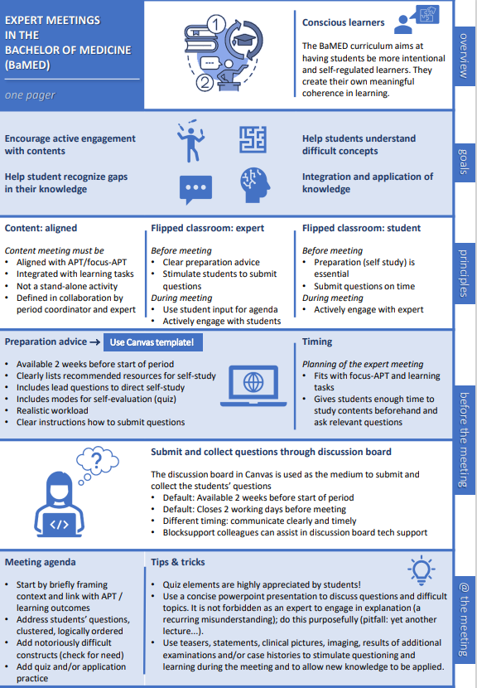

Notes

…………………………………………………………………………………………………………………………………………………
…………………………………………………………………………………………………………………………………………………
…………………………………………………………………………………………………………………………………………………
…………………………………………………………………………………………………………………………………………………
…………………………………………………………………………………………………………………………………………………
…………………………………………………………………………………………………………………………………………………
…………………………………………………………………………………………………………………………………………………
…………………………………………………………………………………………………………………………………………………
…………………………………………………………………………………………………………………………………………………
…………………………………………………………………………………………………………………………………………………
…………………………………………………………………………………………………………………………………………………
…………………………………………………………………………………………………………………………………………………
…………………………………………………………………………………………………………………………………………………
…………………………………………………………………………………………………………………………………………………
…………………………………………………………………………………………………………………………………………………
…………………………………………………………………………………………………………………………………………………
…………………………………………………………………………………………………………………………………………………
…………………………………………………………………………………………………………………………………………………
…………………………………………………………………………………………………………………………………………………
…………………………………………………………………………………………………………………………………………………
…………………………………………………………………………………………………………………………………………………
…………………………………………………………………………………………………………………………………………………
…………………………………………………………………………………………………………………………………………………
…………………………………………………………………………………………………………………………………………………
…………………………………………………………………………………………………………………………………………………
…………………………………………………………………………………………………………………………………………………
…………………………………………………………………………………………………………………………………………………
…………………………………………………………………………………………………………………………………………………
…………………………………………………………………………………………………………………………………………………
…………………………………………………………………………………………………………………………………………………
…………………………………………………………………………………………………………………………………………………
…………………………………………………………………………………………………………………………………………………
…………………………………………………………………………………………………………………………………………………
…………………………………………………………………………………………………………………………………………………
…………………………………………………………………………………………………………………………………………………
…………………………………………………………………………………………………………………………………………………
…………………………………………………………………………………………………………………………………………………
…………………………………………………………………………………………………………………………………………………
…………………………………………………………………………………………………………………………………………………
…………………………………………………………………………………………………………………………………………………
…………………………………………………………………………………………………………………………………………………
…………………………………………………………………………………………………………………………………………………
…………………………………………………………………………………………………………………………………………………
…………………………………………………………………………………………………………………………………………………
…………………………………………………………………………………………………………………………………………………
…………………………………………………………………………………………………………………………………………………
…………………………………………………………………………………………………………………………………………………
…………………………………………………………………………………………………………………………………………………
…………………………………………………………………………………………………………………………………………………
…………………………………………………………………………………………………………………………………………………
…………………………………………………………………………………………………………………………………………………
…………………………………………………………………………………………………………………………………………………
…………………………………………………………………………………………………………………………………………………
…………………………………………………………………………………………………………………………………………………
…………………………………………………………………………………………………………………………………………………
…………………………………………………………………………………………………………………………………………………
…………………………………………………………………………………………………………………………………………………
…………………………………………………………………………………………………………………………………………………
…………………………………………………………………………………………………………………………………………………
…………………………………………………………………………………………………………………………………………………
…………………………………………………………………………………………………………………………………………………
…………………………………………………………………………………………………………………………………………………
…………………………………………………………………………………………………………………………………………………
…………………………………………………………………………………………………………………………………………………
…………………………………………………………………………………………………………………………………………………
…………………………………………………………………………………………………………………………………………………
…………………………………………………………………………………………………………………………………………………
…………………………………………………………………………………………………………………………………………………
…………………………………………………………………………………………………………………………………………………
…………………………………………………………………………………………………………………………………………………
…………………………………………………………………………………………………………………………………………………
…………………………………………………………………………………………………………………………………………………
…………………………………………………………………………………………………………………………………………………
…………………………………………………………………………………………………………………………………………………
…………………………………………………………………………………………………………………………………………………
…………………………………………………………………………………………………………………………………………………
…………………………………………………………………………………………………………………………………………………
…………………………………………………………………………………………………………………………………………………
…………………………………………………………………………………………………………………………………………………
…………………………………………………………………………………………………………………………………………………
…………………………………………………………………………………………………………………………………………………
…………………………………………………………………………………………………………………………………………………
…………………………………………………………………………………………………………………………………………………
…………………………………………………………………………………………………………………………………………………
…………………………………………………………………………………………………………………………………………………
…………………………………………………………………………………………………………………………………………………
…………………………………………………………………………………………………………………………………………………
…………………………………………………………………………………………………………………………………………………
…………………………………………………………………………………………………………………………………………………
…………………………………………………………………………………………………………………………………………………

